Distributor 4110 is used for connection of up to 4 video monitors.
It has 4 ports with RG45 terminals. Each port is assigned to a specific button on the door station as shown:
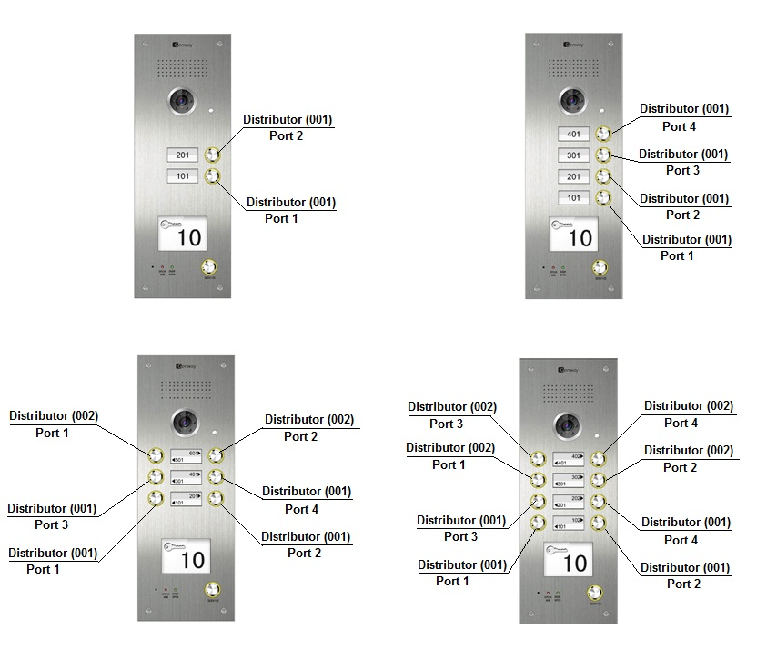

2 and 4-button Door Stations comes with one distributor 4110. Code must be set to 001
6 and 8-button Door Stations comes with two distributors 4110. Code on first must be set to 001 and code on the second to 002 according the diagram below:

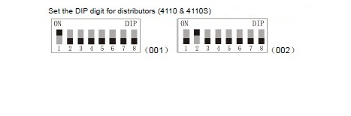
Two type of connection the system

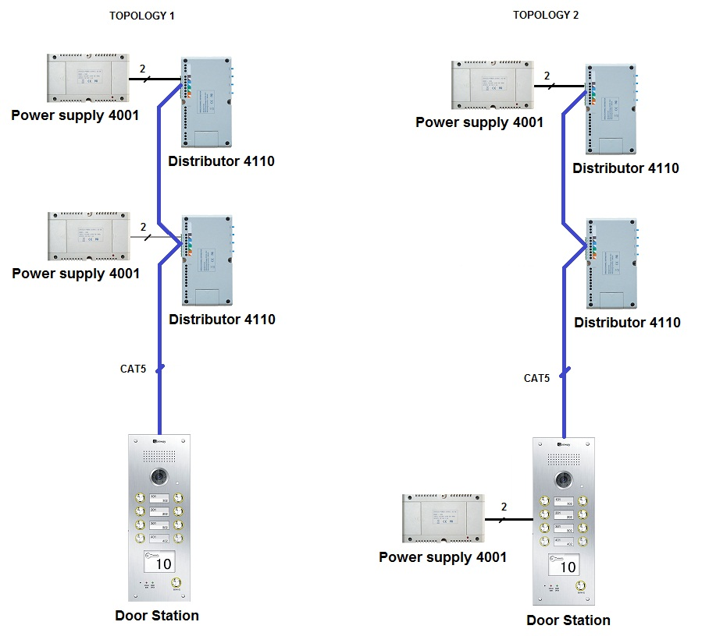

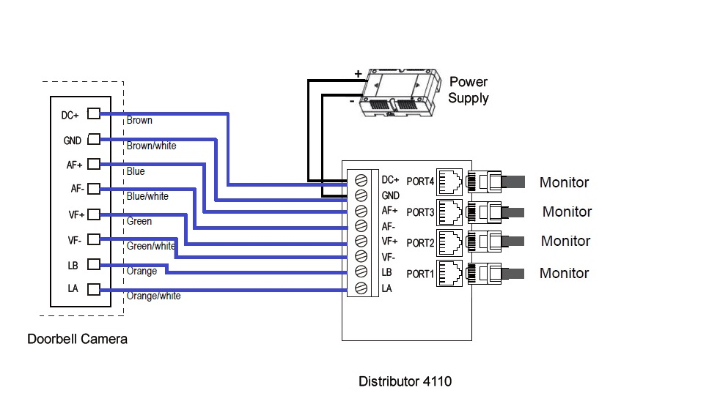
DOOR STATION TO THE DISTRIBUTOR CONNECTION
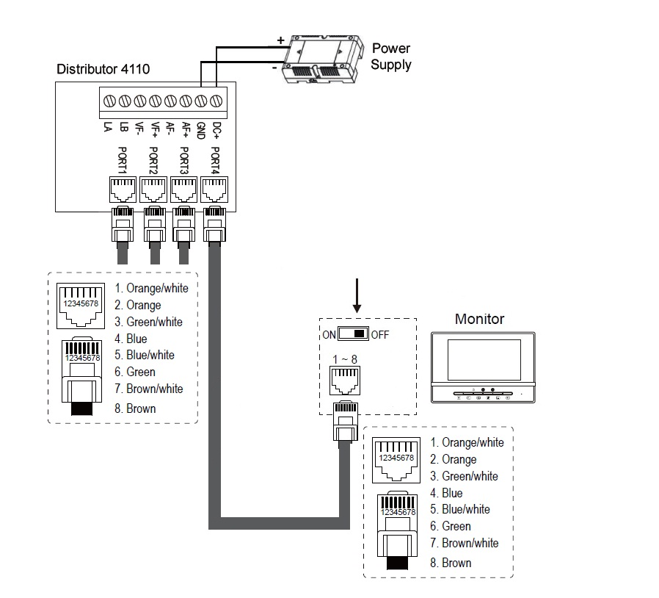
Monitors to the distributor connection

