CRONUS Installation

With DCU
1. Set all dip switches on all devices
a. DIP switch settings on DCU
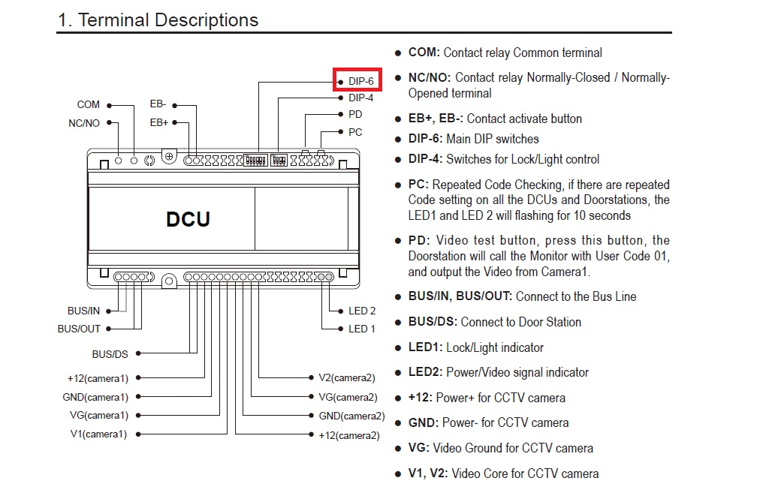
DIP 6 settings: 